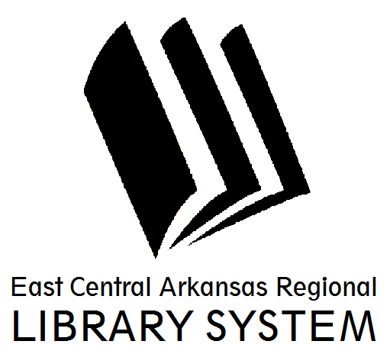
East Central Arkansas Regional Library System
410 E. Merriman Avenue, Wynne AR 72396
PRESS RELEASE

Date: 2/16/17
For more information, contact Claire Miller, Deputy Director 870-587-0580
_____________________________________________________________________________________
Upcoming Events @ Your Library
First, I’d like to thank everyone who participated in Chocolate Feast – making and packing candy or buying candy. We couldn’t do this without you. We are extremely thankful for the Friends of the Cross County Library for supporting our Summer Reading Program and so much more.
Next on the list is Guess Who Family Night at 5pm on March 7th in Parkin. Come and learn some history and compete against your friends. On Thursday, March 8th @ 5pm in Parkin, we’ll be showing Iron Jawed Angels in honor of Women’s History Month. Monday, March 13th at 6pm in Wynne, we’ll be discussing After Alice. Parkin Book Club will be discussing Mrs. Poe on Tuesday, March 14th @ 5:30pm. Teen Book Club will be meeting in Wynne on the same eveing at 6pm. See Mrs. Tree for more information. The Friends of the Cross County Library will be meeting on Thursday, March 16th @ 5pm. All are invited to attend.
Spring Break is almost here and the library has you covered for free entertainment. On Monday, March 20th at 2pm, join us for a Scavenger Hunt. On Tuesday, March 21st at 2pm, get ready for Slime Time. Play clothes are recommended, we might get messy. Wednesday, March 22nd at 2pm come and join the Archaeological Park Explorers and on Thursday, March 23rd at 2pm, join us for Board Games Galore. All of these programs are in Wynne.
For more information on library resources, programming, and more, please visits us online at www.ecarls.org. Don’t forget to like your branch on facebook to keep up with the latest news.

Claire Miller
Deputy Director
Cross County Library
cmiller@crosscountylibrary.org

