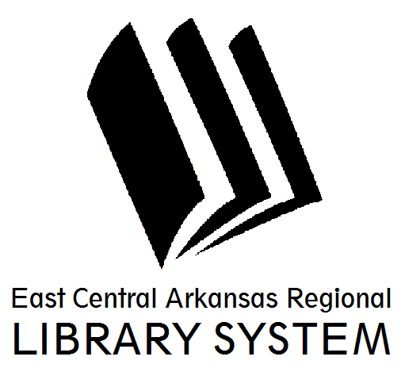
East Central Arkansas Regional Library System
410 E. Merriman Avenue, Wynne AR 72396
PRESS RELEASE

Date: 10/20/2016
For more information, contact Claire Miller, Deputy Director 870-587-0580
_____________________________________________________________________________________
Upcoming Events @ Your Library
We understand that November is a busy month for many people, especially with Thanksgiving coming fast. Don’t forget that your library has books with recipes, decorating ideas, and more to help make the holidays run smoothly. We also have some fun events for all ages to attend in this month. Seated Yoga will be the first Wednesday at 1pm and on the second Tuesday, our teens are meeting for book club at 6pm, both events are in Wynne. If you’re struggling to think of a gift for someone, come to our Let’s Get Crafty event on Thursday, November 10th at 6pm in Wynne. We’re going to make 10 minute Pumpkin Spice Soap. Bring some tissue paper or gift box to take your soap home in. This recipe is simple enough that you can replicate it with other scents at home. All ECARL Libraries will be closed in honor of Veteran’s Day on November 11th. The Club will meet in Wynne on Monday, November 14th at 6pm and Tuesday, November 15th at 5:30pm in Parkin. We’re discussing cozy mysteries with recipes included. We’ll share some of the recipes at the meeting. Friends of the Cross County Library will meet on Thursday, November 17th at 5pm in Wynne. If you’re interested in joining, come see us. We’re hosting Family Movie Night in Wynne on Tuesday, November 22nd at 5:30pm. Join us for a screening of the movie Free Birds. All ECARL Libraries will be closed on Thursday, November 24th in honor of Thanksgiving.
Cross County Library in Wynne is also excited to be partnering with AETN to offer the Mister Roger’s Neighborhood Sweater Drive in November. If you have any gently used, clean sweaters, sweatshirts, hats, scarves, or other warm clothing that you wish to donate, please bring it to your library. All donations will go to the Salvation Army in Forrest City.
For more information on library resources, programming, and more, please visits us online at www.ecarls.org. Don’t forget to like your branch on facebook to keep up with the latest news.

Claire Miller
Deputy Director
Cross County Library
cmiller@crosscountylibrary.org

