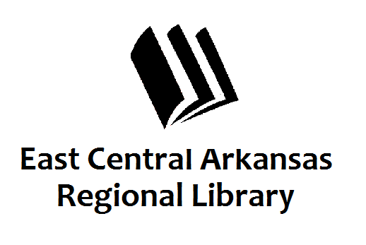
PRESS RELEASE
Date: 6-3-16
For more information, contact:
Claire Miller, Deputy Director at 870-587-0580
_____________________________________________________________________________________
CROSS COUNTY LIBRARY PRESS RELEASE 6-3-16
Library Activities at Farm Fest
Cross County Library has some fun things planned for Saturday, June 11th at Farm Fest. Come to the front lawn to participate in water races, Bubble/Water painting, and some games too. We have some cool prizes to give away too. If you haven’t registered for Summer Reading Program, we can take care of that while you’re there.
Cross County Library is also excited to partner with Farm Bureau on their Annual Bake Off. Participants can drop off their desserts at the library at 10am on Saturday morning. Call Farm Bureau for more information.
If you have any questions, don’t hesitate to call us at 870-238-3850. Press 3 to speak to someone at the front desk. Don’t forget to visit us online at www.ecarls.org and on Facebook. Your local branch has their own Facebook page.

