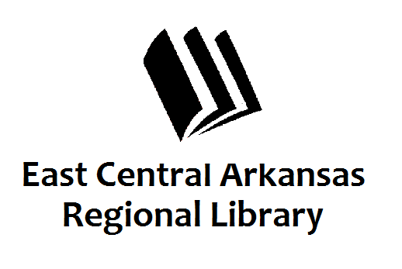
PRESS RELEASE
April 7th, 2016
For additional information, contact:
Angie Meachum, Operations Manager, Woodruff County Libraries at 870-347-5331.

MONEY SMART WEEK

Library Activities to promote Money Smart Week

AUGUSTA, Apr. 21st-29th –April 21st-29th the Augusta Library programming will be promoting Money Smart Week. A money smart week display will be provided by the home extension office at the Library. April 21st at 11:00 at the First Baptist church in Augusta the 50+ club will be host to the Attorney General’s Office and a senior scam program that teaches senior citizens to be aware of scams that prey on older adults. Miss Melinda’s story time on the 28th at 4:15 will be geared towards how children can save and be responsible with their money. Money Smart Week is a public awareness campaign designed to help consumers better manage their personal finances. This is achieved through the collaboration and coordination effort of local organizations. Money Smart partners include community groups, financial institutions, government departments and schools to promote financial awareness. These groups come together once a year to stress the importance of financial literacy. For more information, please call Angie or Karen at 347-5331. The Library is located at 201 Mulberry St.

