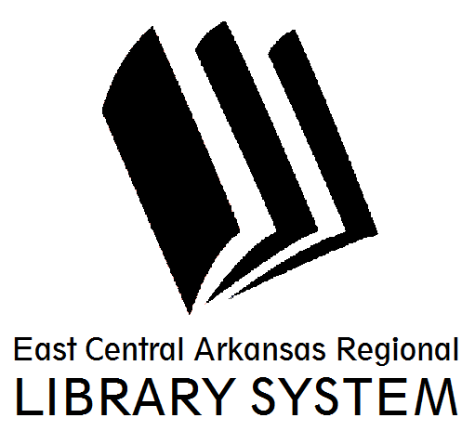
BOARD OF TRUSTEES MINUTES
May, 22, 2014

Call to Order and Roll Call: The meeting was called to order at 12:10 pm at the Cross County Library in Wynne, Arkansas. Kitty Bingham, Joy Lynn Bowen, George Anne Draper, Anne Eldridge, Reta Ragland, Angela Ryland, Erleen Sawyer, and Joy Shepherd were in attendance.

Trustees absent: Bill Brooks, Kip Davis, and Carolyn Imboden.

Public Attendees and staff: Claire Miller, Branch Manager of Cross County Library; Angie Meachum, Branch Manager of Woodruff County Library and John Paul Myrick, ECARLS director. Ruth Hyatt from the Arkansas State Library was also in attendance.

Reading and Acceptance of Minutes.

The ECARLS Trustees read the minutes from the ECARLS Board Meeting on February 7, 2014. Joy Lynn Bowen moved to accept the minutes, Angela Ryland seconded the motion. All aye. Motion carried.

At 12:20, the meeting was stopped so that Ruth Hyatt could present a training for the Trustees. The meeting was reconvened at 1:16pm.

At this time, Executive Director John Paul Myrick introduced the two new Woodruff County Trustees, Anne Eldride and Angela Ryland and asked that all of the trustees introduce themselves.

Public Participation and Communications:
- N/A

Financial Reports and approval of bills:

Financial Reports were presented for April 2014. Joy Lynn Bowen moved to accepted the financials as presented, Joy Shepherd seconded the motion. All aye, motion carried.

Operation Reports:

The Trustees were presented with reports from the Branch Managers in Cross and Woodruff Counties as well as a report from the Regional Librarian. Joy Shepherd asked Claire Miller for a summary of the programming for the 2014 Summer Reading Program. Claire discussed the themes for children, teens, and adults and highlighted the programming schedule for the Summer. There was also discussion about the kickoff event with author Eric Litwin. John Paul Myrick asked Angie to discuss the Summer Reading Program in Woodruff County also. Angela Ryland moved to accept the reports as presented, Joy Lynn Bowen seconded the motion. All aye, motion carried.

Unfinished Business:

John Paul Myrick presented the findings of the ECARLS 2013 Audit. Segregation of duties was the only finding and it is very common for small businesses. Reta Ragland moved to accept the ECARLS 2013 Audit, George Anne Draper seconded the motion. All aye, motion carried.

Next, discussion resumed about the proposed revision of the ECARLS Policy Manual. Reta Ragland moved to approve the revision of the ECARLS Policy Manual, Angela Ryland seconded the motion. For discussion, George Anne Draper asked about the proposed checkout limit for the child’s card. Currently it is 20 items, but the proposed change will make it 10 items. George Anne asked the Branch Managers and they answered that children usually don’t check out 20 items, it’s usually 5. George Anne was satisfied with the responses. All aye, motion carried.

John Paul Myrick then presented the proposed revision of ECARLS Bylaws for approval. Specific changes discussed were as follows: providing the option to vote by proxy, Direct Deposit for employee paychecks and election of officers. Payrolls for the system libraries would be merged and paid for out of one, single account to be opened by the Executive Director in a local depository. No signatures would be required for electronic payments as long as they are within budgeted appropriations. Joy Lynn Bowen moved to accept the proposed revisions of the ECARLS Bylaws and the Director’s recommendations, Erleen Sawyer seconded the motion. All aye, motion carried.

New Business:

John Paul Myrick then presented the Forrest City Library Proposal. This proposal suggests that the Board vote to all Forrest City Public Library to join the East Central Arkansas Regional Library System as an affiliate member. This would allow the Forrest City Public Library to have two trustees on the ECARLS Board. Citizens of Forrest City would be allowed to use our library services for free and our patrons would receive the same benefits from Forrest City Public Library. Citizens outside of city limits of Forrest City will have to pay a $25.00 fee unless the work or attend school in Cross our Woodruff Counties. The Arkansas State Library is fairly certain ECARLS will receive additional state funding to aid us in providing this service. This proposal was presented to the ECARLS Board prior to discussing it with the Forrest City Public Library. This proposal also offers the partnership on a trial basis to see if it will work to everyone’s benefit. Angela Ryland moved to approve the Forrest City Library Proposal, Anne Eldridge seconded the motion. All aye, motion carried.

Lastly, John Paul Myrick made a recommendation to extend use of the current 2013-2014 ECARLS budget through August to make sure further changes don’t need to be made. On a motion by Draper and seconded by Shepherd, the board unanimously agreed to this recommendation.

Trustee Comment Period:

- N/A

Adjournment: Reta Ragland motioned to adjourn the meeting, Angela Ryland seconded the motion. All aye. Motion carried. The meeting was adjourned at 2:00pm.

Respectfully submitted,

Claire Miller, Branch Manager of Cross County Library

