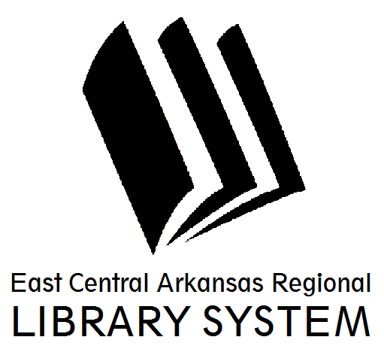
East Central Arkansas Regional Library System
410 E. Merriman Avenue, Wynne AR 72396
PRESS RELEASE

Date: 9/1/2016
For more information, contact Claire Miller, Deputy Director 870-587-0580
_____________________________________________________________________________________
Kimberly Shawn Brown Art Show at Cross County Library
Cross County Library is excited to partner with the Cross County Arts Council to host an art show and reception by former Wynne native, Kimberly Shawn Brown. The show will feature new encaustic paintings from Chicago Art Galleries. The reception will be on Thursday, October 6th from 5pm to 7pm in the Lolly Shaver Program Room. The artwork will be available for some viewing on Friday, October 7th. Light refreshments will be served. If you’d like a preview of Kimberly’s work, you can visit her online at www.kimberlyshawnstudio.wordpress.com.
For more information on library resources, programming, and more, please visits us online at www.ecarls.org. Don’t forget to like your branch on facebook to keep up with the latest news.

Claire Miller
Deputy Director
Cross County Library
cmiller@crosscountylibrary.org

