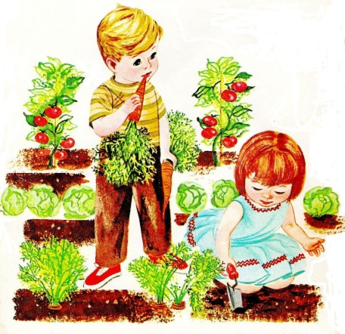
Honey of a garden
Kids over the age of 5 are invited to get their hands dirty while learning the basics of gardening. Learn in 30 minutes what it takes for plants to grow, look pretty along with producing something good to eat.
Monday, April 11
5:00 pm
Woodruff County Library – Augusta
201 Mulberry, Augusta

Conducted by Woodruff County Extension Service. Examples will available to take home.
For more information call 870-347-2556
The Arkansas Cooperative Extension Service offers its programs to all eligible persons regardless of race, color, sex, gender identity, sexual orientation, national origin, religion, age, disability, marital or veteran status, genetic information, or any other legally protected status, and is an Affirmative Action/Equal Opportunity Employer. The Arkansas Cooperative Extension Service is an equal opportunity/equal access/affirmative action institution. If you require a reasonable accommodation to participate or need materials in another format, please contact your County Extension office (or other appropriate office) as soon as possible. Dial 711 for Arkansas Relay.

